**Sequence Diagram:**

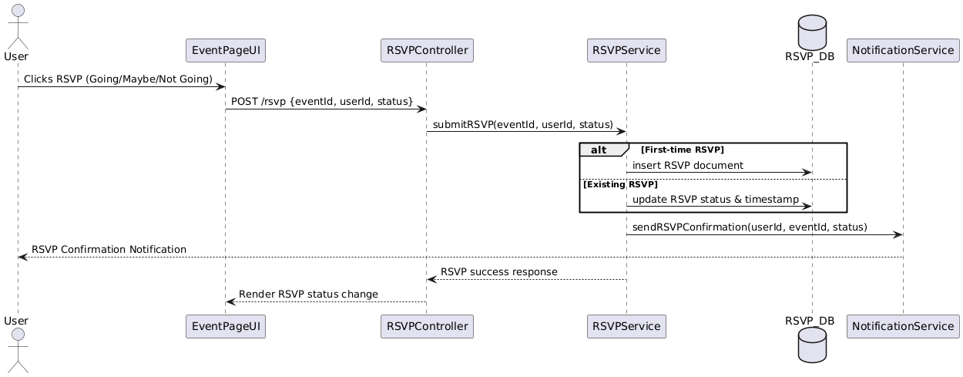

**Class Diagram**

**State Diagram**

**ERD**

**Functional Requirements**

1. Authenticated users should be able to RSVP to any public or invited event.
2. RSVP options include Going, Not Going, and Maybe.
3. User’s RSVP is stored with a timestamp and can be updated before the event.
4. Only one active RSVP status per user per event is allowed.
5. Users can view their RSVP status across all events.
6. Event organizers can view full RSVP lists categorized by status.
7. System automatically closes RSVP 15 minutes before the event begins.
8. Notifications are sent to the user when their RSVP is confirmed or updated.

**Non-Functional Requirements**

1. RSVP response time should be under 500ms.
2. Scalable to handle 10,000 concurrent RSVPs per minute.
3. System must be available 99.99% for RSVP and attendance tracking.
4. Only authorized roles (event creator/admin) can view attendee lists.
5. Data should be encrypted at rest and in transit.
6. Audit log should be maintained for all RSVP changes for 12 months.